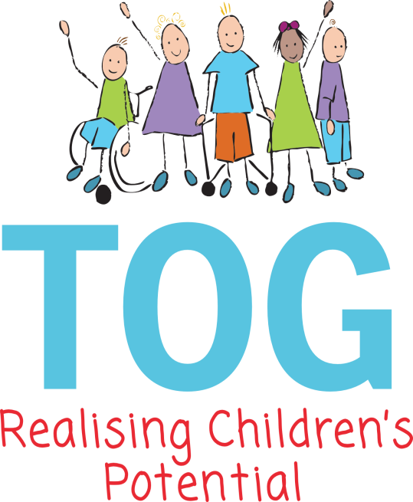

Managing Staff and children’s Behaviour.

Aim

We aim to promote good standards of behaviour amongst the staff and children attending our Group and to help them develop an awareness of respect for each other.

Named Member of Staff

The Manager/Deputy has responsibility for behaviour management issues.

Admissions

TOG is a preschool for children with Special Educational Needs and as such we accept children who are referred to the Group where there may be concerns about behaviour.

Principles:

All staff working in Taunton Opportunity Group, including visiting Professionals adhere to the following principles:

- Working together to safeguard and promote the welfare of children.
- Working together in partnership with the family.
- Consistency of approach across settings and agencies, including the family.
- The promotion of independence, choice and inclusion to enable children maximum opportunity for personal growth and wellbeing.

Planning and Organisation
- TOG provides well-planned learning opportunities that consider children’s interests and abilities to foster the children’s attention, interest and positive attitudes to learning.
- Adults provide an essential role in promoting children’s self-esteem by valuing and praising their efforts. Children’s self-esteem is also encouraged by giving the children responsibility throughout the session.
- Adults use appropriate levels of language supported by a total communication approach, to support the children’s learning.
- Adults provide good role models by behaving both courteous and respectful to the children as well as to each other.
- There is a clear and consistent routine to the morning sessions that enables the children to learn to predict what will be happening and what is expected of them.
- Adults set clear expectations and boundaries for children by responding consistently to situations.
- Emphasis is placed on planning activities that encourage children to practise skills such as becoming aware of each other, taking turns and sharing.
- We work hard to develop positive relationships with parents and provide opportunities to talk about issues, concerns and achievements both formally and informally.

Encouraging Positive Behaviour:

- We strongly believe in creating a learning environment where all the children’s efforts are valued and praised.
- Praising what has been done e.g. “Good Sharing” reinforces good behaviour.
- Adults support children to share toys and to wait their turn by modelling appropriate language and prompting the desired responses.
- Adults respond calmly and consistently to the children.
- Adults encourage children to take responsibility by e.g. helping another child, taking the plates round at snack time etc.
- Adult’s help children become aware that behaviour can be hurtful to others according to the level of understanding the child has.
- We reassure children that whilst inappropriate behaviour is unacceptable they are still valued and cared for.
- We follow ‘all emotions are ok’ and have visual props and books to help with all emotions and self-regulation.

Managing Challenging Behaviour:

- Physical punishment is never to be used at TOG and any adult seen administering this would be immediately subject to disciplinary procedures.
- Wherever possible children’s achievements and good behaviour are warmly praised.
- Key person observations will help us to identify possible triggers and strategies regarding unacceptable behaviours and ‘ABCC’ records would be completed and analysed.
- We will try to distract or deflect children’s intentions towards another activity or situation before the incident occurs.
- We may ignore or give minimal attention to children exhibiting certain behaviours but then praise them as soon as they respond positively.
- Changes are made to routines or the organisation of resources if observations show that this could help resolve situations.
- Responses to a child’s behaviour should always be made at an appropriate level to his or her needs. This may just be the word “Stop!” or a simple discussion as to why he or she shouldn’t do that.
- A child is sometimes removed from a situation if it is felt his/her own, or others safety is compromised.
- Adults will not use negative language about or to a child such as “Naughty Boy” and must not seek to humiliate a child.
- Adults should avoid discussing children’s behaviour in front of them or others.
- A team approach is used when resolving behaviour issues and we seek to involve the child’s parents when doing this so that we can all be consistent in our approach to the issue.
- A Managing Feelings and Behaviour Plan may be drawn up in consultation with all staff and the child’s parents.

Physical Intervention:

Physical restraint should rarely be used and only to prevent a child harming himself or others (paragraph 1.82 Section 550A Education Act 1996).

- If this was needed an incident report would be completed and shared with parents.
- Advice would be sought from the educational psychologist and a plan written in conjunction with the parents.

Bullying:
Amongst Children:

- Due to good adult child ratios and clear expectations of behaviour it is hoped that bullying is unlikely to occur.
- Where staff become aware of bullying or are made aware of it by a parent, then steps would be put in place to ensure that it stops e.g. increased supervision, reorganisation of the room, resources etc.
- The parents of the child will be kept fully informed of the intervention and its outcomes.

Amongst Adults:

- TOG is committed to ensuring that its staff and volunteers are suitable to work with children and would not bully or harass children or each other.
- TOG expects adults working within the Group to challenge any bullying that they see and report it in writing to the Chair of the Committee, who would investigate the matter.
- We expect all staff/volunteers and students to be always respectful of each other and will challenge any negative behaviour immediately.

Informing Parents:

- We aim to develop positive relationships with parents of the children attending our Group.
- There are opportunities for informal discussions between parents and staff at the beginning or end of each session.
- Formal appointments can be made to discuss issues in more detail.
- If a significant incident has occurred then this would be recorded in the Incident Book and discussed with the parents, away from the children, in a private area and they would be asked to sign it.
- Where individual strategies are put in place then these would always be shared and documented with the parents and their advice and support would be sought from the beginning.
- Any decision to ask for additional advice from external support agencies would be made jointly with parents.
- A summary of the policy is included on TOGs website.

Training:

- All new staff and volunteers will be emailed a copy of the policy and talked through the approaches that we use.
- Staff are encouraged to attend relevant training workshops on behaviour as provided.
- There are opportunities to discuss issues concerning behaviour at our weekly planning meetings and each morning before the children arrive.

This policy will be reviewed annually.
Date of this review: - 2026 August

Last Review: - May, September 2025

