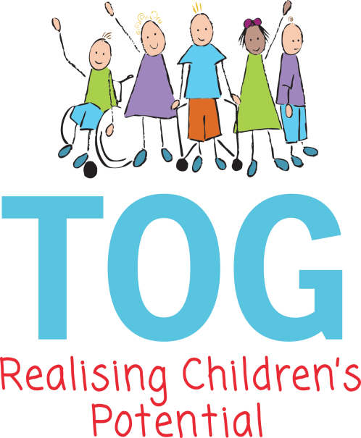

Equal Opportunities Policy

‘Providers must have in place arrangements to support children with SEN or Disabilities’

This Policy must be read in conjunction with TOG’s Special Educational Needs Policy

Aims:

- Taunton Opportunity Group is committed to equality of opportunity for all its children and families as well as its employed staff.
- Taunton Opportunity Group values all of the children and their families who come to TOG and we welcome the diverse family structures, languages, gender, faith, race, culture and disabilities that are represented by families and staff.
- We aim to provide a learning environment that engenders British values and positive attitudes to all children and their families.
- We ensure that all children have the same equality of access to the learning experiences provided within the Group and we value each child’s contribution, recognising their individual needs and abilities.

Equality Needs Coordinator:

- All TOG staff are appointed ENCO’S’s and are responsible for coordinating the implementation of this policy.
- Due regard is given to the legal requirements relating to Equality, Inclusion and Racial Awareness.

Admissions and Induction:

- TOG has a clear admission policy that indicates that we are a pre-school provision for children with special needs.
- We arrange any necessary training that would enable a child with complex needs to attend the Group.
- We have a flexible induction programme that can be adapted to meet the needs of individual children and their families.

Partnership with Parents:

- We endeavour to ensure that all parents feel valued and included. We share information with families via emails, facebook and through either formal or informal meetings
- We aim to provide information in different ways according to the individual needs of the families attending the Group and would seek to find out about their language, individual customs, beliefs and values through face to face meetings.

Curriculum:
Wooden Spoon House, Crowcombe Road, Taunton, Somerset, TA2 7NF. Tel 01823 284550
Email admin@tauntonopportunitygroup.org.uk Web www.tauntonopportunitygroup.org.uk Twitter @TogTaunton Charity No 277984

- All children at TOG have access to the Early Years Foundation Stage.
- We plan learning opportunities that are based on our assessments and observations of the children enabling each child’s individual needs to be met.
- We are able to make use of the wide range of resources and specialised equipment that we have at TOG, as well as liaising with visiting professionals, so as to maximise the potential for each child.
- Individual differences, similarities and achievements amongst the children are valued and praised throughout all sessions.
- Children are taught to value and respect each other through adults modelling these values in their relationships with the other adults in the Group and in their interactions with the children.
- We provide learning opportunities that raise the children’s awareness of the world around them and which reflect their own family backgrounds, through a variety of means such as posters, communication aids, specialised seating, music, food, aromas and linking art work to major festivals.

Accommodation, Staffing and Resources:

- We aim to provide a welcoming environment and have a building that is accessible.
- TOG aims to be an equal opportunities employer and advertises vacancies in a variety of media.
- All staff are encouraged to take up training regarding equal opportunities and are made aware of these through weekly staff meetings. Volunteers are also informed of any appropriate training.
- We aim to develop a range of resources that will reflect positive images of diverse family structure, faith, race, culture, disability and gender.
- TOG’s resources are accessible for children with special educational needs and equipment is adapted as necessary.
- Reasonable adjustments would be made to either the environment or equipment if this was shown to be needed and would be the responsibility of the Management Committee to implement.

Teaching and Learning Styles:

- We use a wide range of teaching strategies at TOG that are tailored to individual needs, such as large and small group teaching and support and opportunities for individual support where needed. Planned learning opportunities reflect a mixture of adult directed activities and child led play activities. We have a range of equipment and communication aids that enable us to make activities accessible for all children.
- We value all children who attend and aim to promote their self-esteem and confidence by positively reinforcing their achievements.
- We provide a safe and supportive environment. We encourage staff to help children gain an awareness of the needs, cultures and beliefs of others.

Behaviour:
- TOG has a separate behaviour policy, which informs this statement.
- We promote good behaviour by praising appropriate behaviour and setting clear boundaries. We also value all emotions matter and will use props and books to help the children to understand theirs.
- We use positive reinforcement of appropriate behaviours and adults working within the Group are also expected to model good standards of behaviour.

Challenging Inappropriate Attitudes and Practises:
- All staff are made aware through this policy and during induction procedures, that they must bring any discriminatory behaviour and attitudes to the attention of the Manager or deputy.
- Any member of staff, volunteer, student or parent exhibiting discriminatory behaviour will be advised that it is not acceptable within TOG’s premises.

Links with other Agencies:
- We will endeavour to liaise with outside agencies for support in meeting the aims of this policy.
- TOG is fortunate in having good, regular links with a variety of agencies involved in the care and intervention for pre-school children with special needs.

Health and Safety:
- Where a referral or individual risk assessment on a child highlights potential issues such as training needs for staff, then an appropriate action plan would be put in place, e.g. accessing training to meet the medical needs of a child.
- We aim to include all our children into all our activities and would seek external support to help us surmount any difficulties which may otherwise impede our ability to fully include a child.

Complaints Procedure:
- TOG has a Complaints Policy.

Monitoring of Policy and Evaluating Effectiveness of Inclusive Practises:
- This policy will be monitored through staff observations on the children and the learning opportunities provided for them.

This policy will be reviewed annually.
Updated 2026
Date of this review: - September 2025

