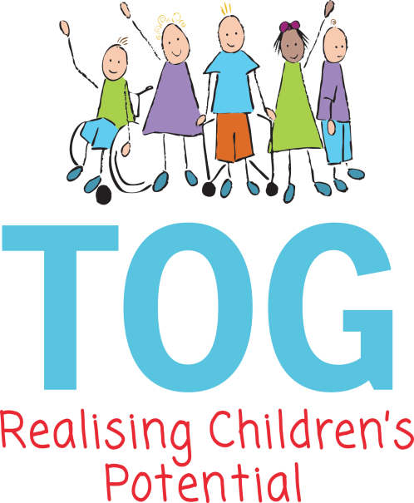

Special Educational Needs Policy

This Policy must be read in conjunction with TOG’s Equal Opportunities Policy

Taunton Opportunity Group is a pre-school provision for children with special educational needs. The Special Educational Needs Code of Practice 0-25years, (2015, p15), provides a definition of special educational needs as follows – “A Child or young people has special educational needs if they have a learning difficulty or disability which calls for special education provision to be made for him or her.” This statement relates to all the children who attend the Group.

Aims:

- TOG aims to assess and identify the special educational needs of the children attending the Group and to then put in place appropriate intervention in accordance with the SEN Code of Practice 2015 and Somerset Core standards. We also work in very close partnership with our parents.
- We aim to offer a quality provision for all the children who attend the Group, providing planned learning experiences that reflect the needs of the children and which follow the Early Years Foundation Stage.
- All the children will be fully included in the setting and will have access to all the activities provided by the Group at a level appropriate to their needs.
- TOG aims to ensure that all the children who attend feel respected, valued and motivated to learn.
- TOG aims to involve parents and carers in their child’s learning and to offer support to them throughout their involvement in the group.
- We will liaise with other professionals involved with the children so as to ensure that there is a coordinated approach when planning appropriate targets and strategies for the children.

Equal Opportunities:

- All children at TOG will have the same opportunities to participate fully in the learning experiences provided by the Group regardless of their disability, ethnicity, race or gender and TOG will actively promote British Values. Please see our Equal Opportunities Policy.
- We are able to ensure that all the children can participate fully by using our observations to plan developmentally appropriate activities, differentiating targets for individual children and using specialist equipment to help adapt activities where necessary.
- All staff, volunteers and students are encouraged to help all the children participate as fully as they can and to value all their achievements.

Admissions:

- Children are referred to TOG by parents/and a variety of professionals. There is a formal Admissions Policy that is adhered to when offering a place at TOG for a child. We would ask the parents if an EHA (Early help Assessment) form had been completed and by whom, we would then request parents’ permission to obtain this information to request Area Senco/Inclusion advisor involvement and other Professionals.
- The Admissions Policy encourages a flexible approach to how a child is settled into the Group according to his or her individual needs. TOG staff will work individually with parents to work out what will be best for them and their child.
- We would work out a managing feelings and behaviour plan with parents to cope with any behavioural difficulties that may be causing concern. We would seek advice and support from external agencies to help us intervene appropriately rather than exclude the child from the Group. Where difficulties remained after a period of sustained intervention, there would be further discussions and further advice sought.
- Where medical issues may be a concern as to a child attending the Group, we would seek the appropriate training for staff members and additional resources where necessary.

Access and Accommodation:
- TOG’s building/premises is accessible to both children and adults with disabilities. It is all on one level and there are no steps apart from the side entrance.
- There are changing facilities at TOG that are appropriately sized for pre-school children, but an assessment would need to be taken if an older child or adult needed changing facilities at the Group. We have a manual hoist and are trained in manual handling and each individual child’s lifting. All children requiring the hoist will have a risk assessment and procedure filled out by the child’s Occupational therapist.

Partnership with Parents:

- A key aspect of this policy involves consulting with and involving parents in their child’s learning.
- All staff are expected to be sensitive towards parents and to actively listen to their concerns.
- Consultations with parents may be via formal or informal meetings, reviews, reports, special educational needs plans, school entry planning meetings etc.
- We contact parents with whom we do not have daily contact to arrange times when it is convenient for them to come in and share information about their child’s progress etc, and in adverse weather conditions be in contact with all families.
- Children aged two and younger must be accompanied by a parent or main carer to our stay and play session and this provides opportunities to share information and ideas.
- All written information given to parents is clear and we can talk it through with a parent if preferred.
- Our local offer is available on our website.

Curriculum Planning:

- TOG gives due regards to the SEN Code of Practice.
- The Manager is responsible for coordinating the provision for the children attending the Group.
- For those Children attending TOG who are identified as being Early Years High Needs, Group planning is put in place for those children and SEN Assess, plan, do, review are drawn up for those children on Early Years High needs funding. This is in line with Somerset’s interpretation of the Code of Practice.
- Special Educational Needs Support Plans are shared with parents and implemented within the sessions.
- We use the Early Years Foundation Stage plus other curricular materials such as the Developmental Journal and Multiple Needs Development journal to break learning opportunities down into achievable steps for individual children.
- Observations and activity records also help in planning appropriate intervention for children. We also use the 2-year check, trackers, Ecats, and individual provision plans, these also help in monitoring children’s progress or areas of concern.
- Visiting Therapist’s advice and contribute with individual care plans for the children.
- The learning environment at TOG incorporates a Total Communication including Hanon language approach as a basic entitlement for all children.

Links with other Agencies:

- TOG has input from Speech and Language Therapy and Occupational Therapy and physiotherapy. We can also request involvement via an EHA.
- TOG has a good liaison with external support services such as the Educational Psychology Team, Hearing, Vision. And ITS (integrated therapists)
- We have good links with Health Visitors and share 2-year checks.
- TOG has an Area Senco and Inclusion advisor it can contact for advice; parent’s permission will be sort for TOG staff to discuss their child.
- Regular liaison takes place between TOG and the local pre-schools that the children also attend.
- “MAISEY” consultation meetings, involving education, health and social service Professionals are held half termly, parent’s permission needs to be sought for this.

Staffing and Resources:

- The Manager coordinates all SEN provision within the setting and is responsible for ensuring all staff are involved in meeting and providing for the children’s needs.
- We have a high staff ratio of one adult to three children, which helps us to respond to children’s needs and where necessary can provide one to one support.
- All staff are encouraged to undertake appropriate training in this area.

Complaints Procedure:

- TOG has a complaints policy. (See the Complaints Procedure).

Monitoring and Review:

- It is the Managers role to ensure that all staff and volunteers are aware of this policy and that they follow it.

This policy will be reviewed annually.

Date of this review: - August 2026

Last Review: - September 2025

